

Go2FA User Manual V1.0

(MOBILE)

Project Team: SS18/1F

Produced by: Koh Hong Wei (5363536)

Chua Han Ming Adler (5710923)

Ong Wei Hao (5711356)

Supervisor: Dr Ta Nguyen Binh Duong

Contents

1. Introduction 3

2. Requirements 4

3. Register Account 5

4. Log In 7

5. Main Menu 12

5.1. Lock 13

5.2. Unlock 16

5.3. View File **Error! Bookmark not defined.**

5.4. View History **Error! Bookmark not defined.**

5.4.1 View File History by Date **Error! Bookmark not defined.**

5.4.2 View Login History by Date **Error! Bookmark not defined.**

6. Change Password **Error! Bookmark not defined.**

# 1. Introduction

Welcome to **go2FA User Manual (MOBILE)**. The objective of this document is to allow user to understand the functionalities of go2FA application on Android mobile. This is a step by step user guide to ensure smooth usage of our application.

# 2. Requirements

|  |  |
| --- | --- |
| Recommended System Requirements | |
|  | Android |
| Connectivity | Wi-Fi 802.11 a/b/g/n/ac), Internet Connection(3G/4G) |
| Operating System | Android Version 6.0 (Marshmallow) and above |
| RAM | 1GB |

# 3. Register Account

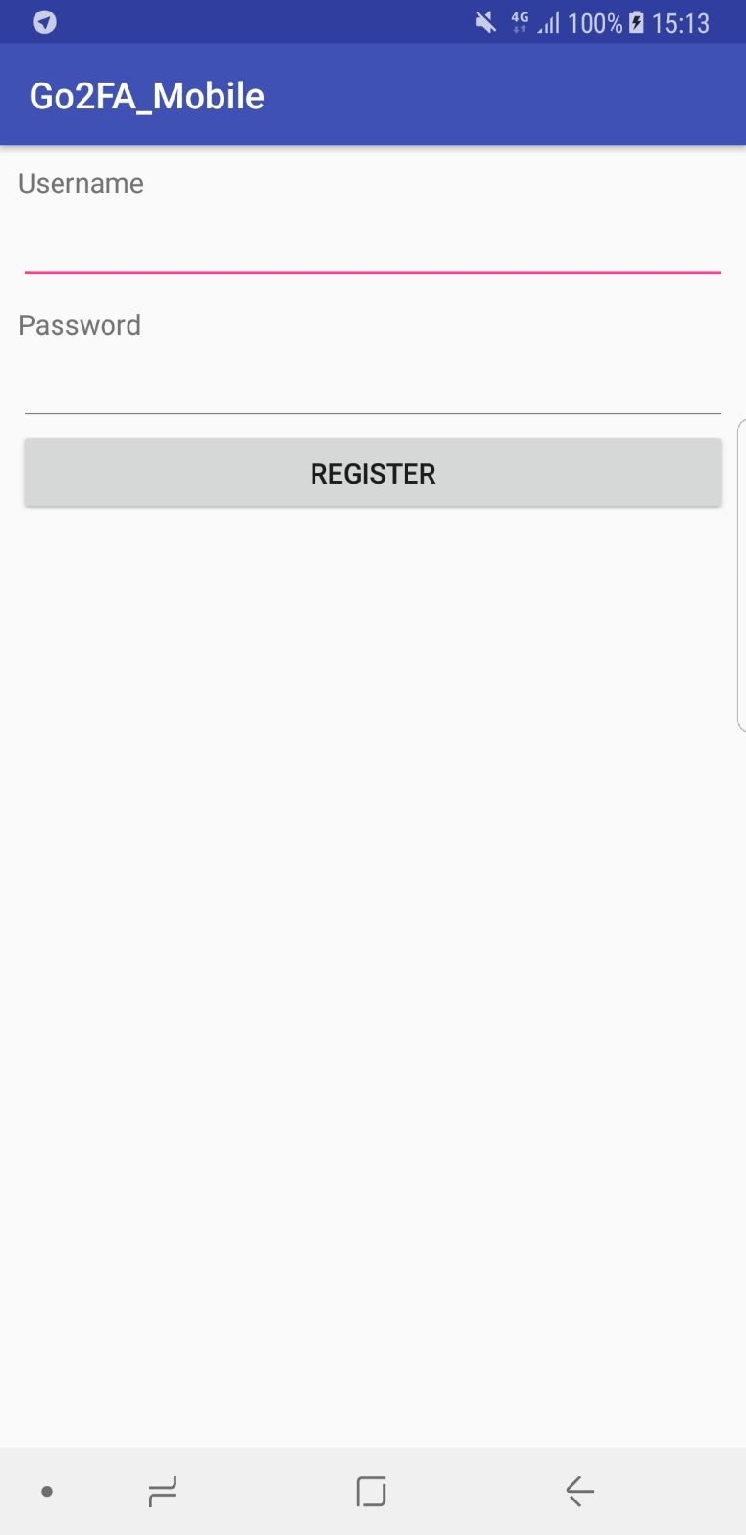

This is the Register Account page for Android Mobile Application.

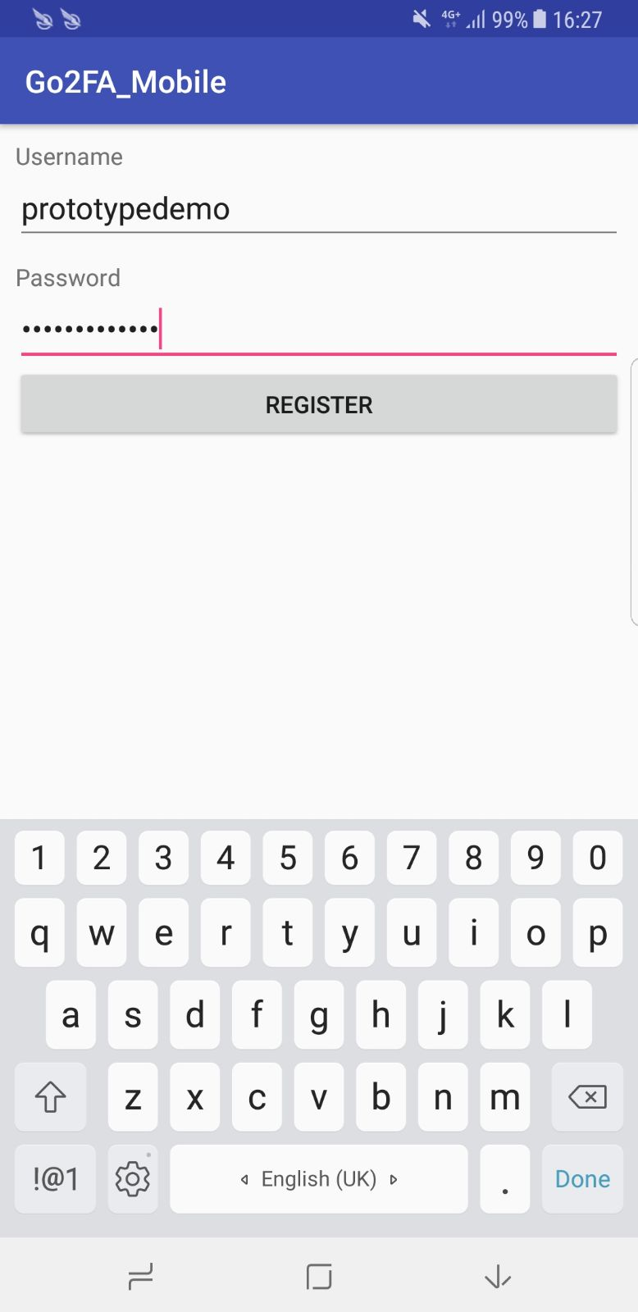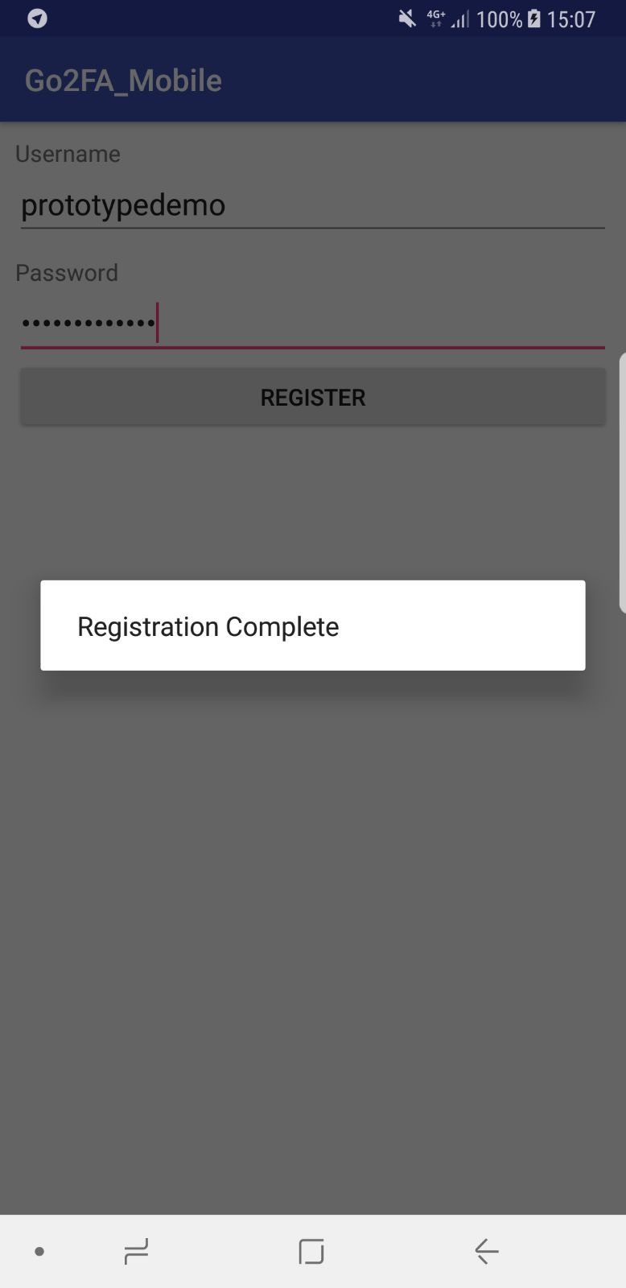

Upon entering the desire Username and Password for account registration, a prompt will appear indicating that the account has been created successful.

# 4. Log In

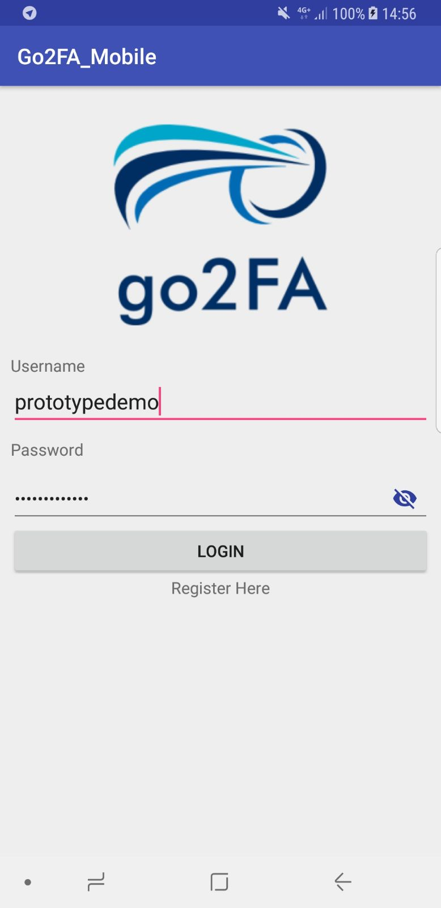

This is the log in page when the application is launch, simply key in the Username and Password that has been created to use our system.

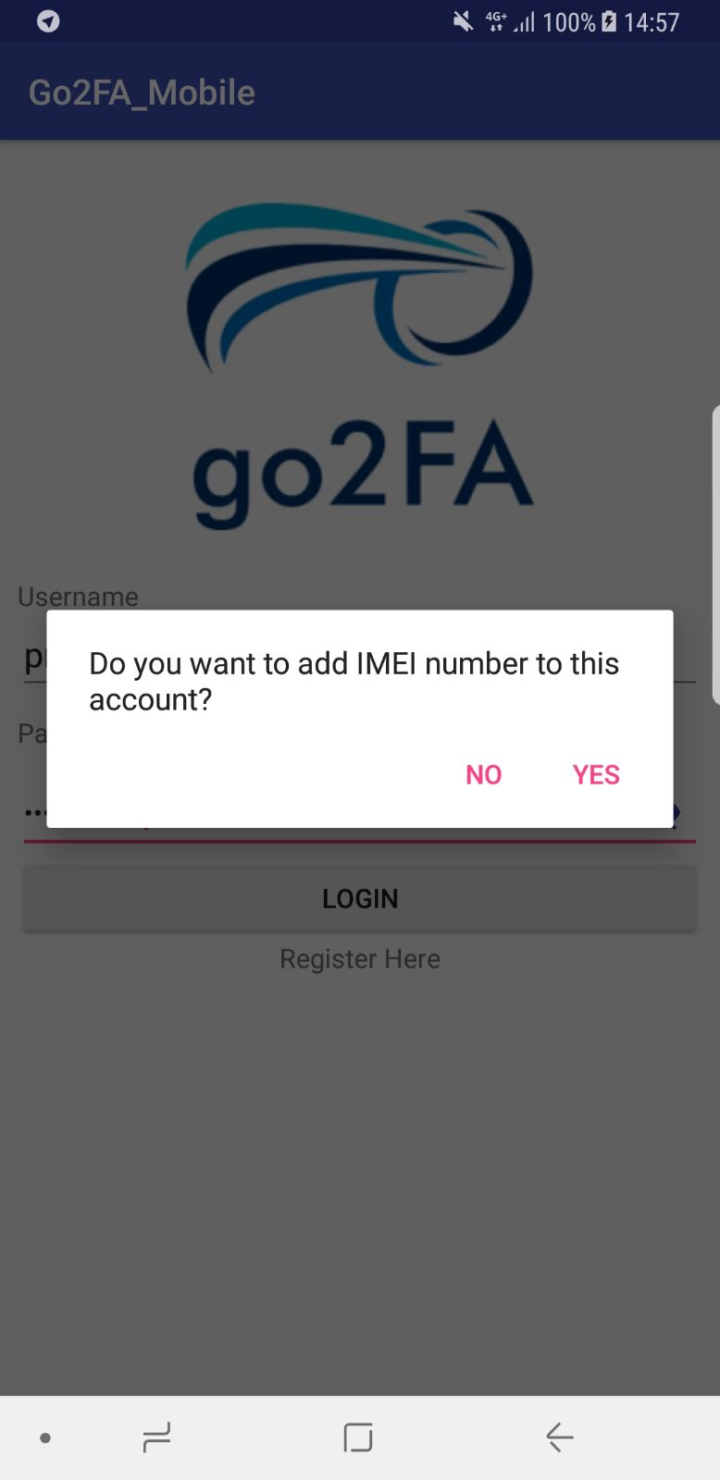

When successful logged in, system will prompt a message indicating if you would like to register your account to this mobile device. This is only required during initial log in.

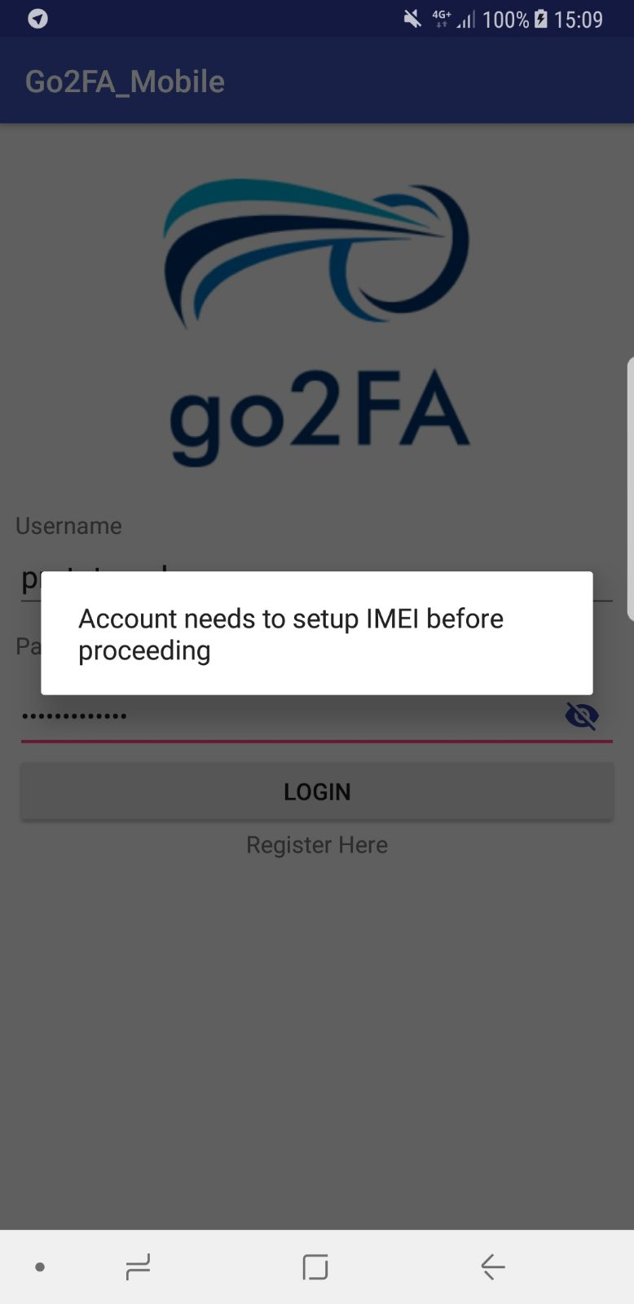

If the choice you selected is NO, you will not be able to proceed to main menu.

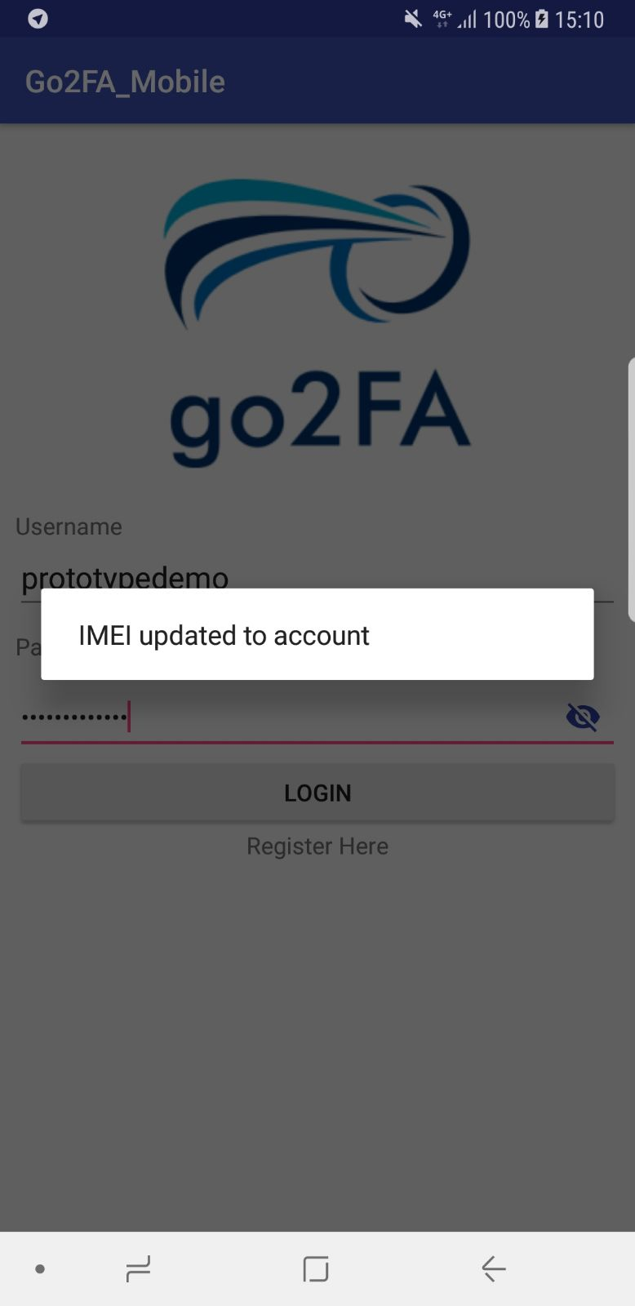

If the choice you selected is YES, your IMEI number will be tagged to your account and updated in our database.

You will then be proceeded to the main menu

Note that if your account is tagged to a mobile device, your account cannot be used on another mobile device that isn’t registered as one account can only be tagged to one mobile device.

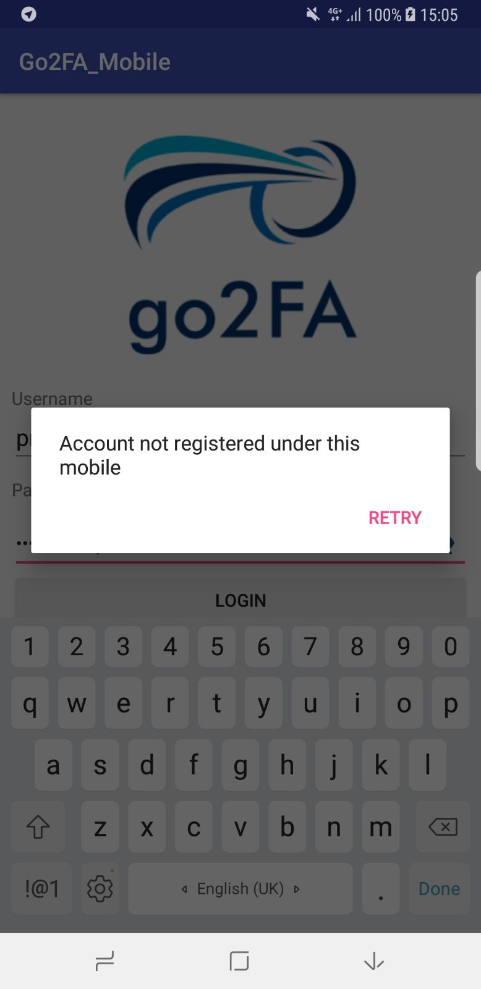

A message will be prompted if you are using your account on a mobile device that is not tagged under your account details and you will not be logged in.

# 5. Main Menu

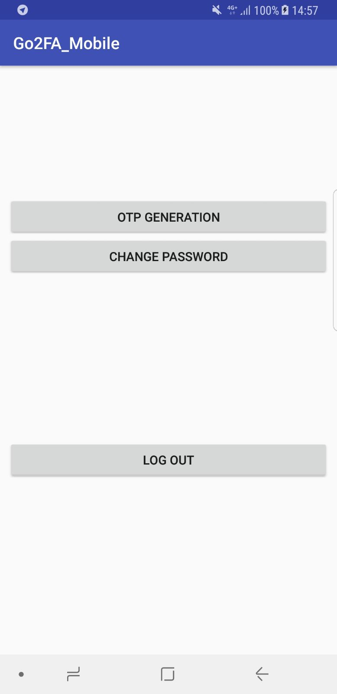

After logging in, welcome to our application’s main menu. This is where you can select the OTP generation function provided by our application to help protect your files on your computer.

## 5.1. OTP Generation

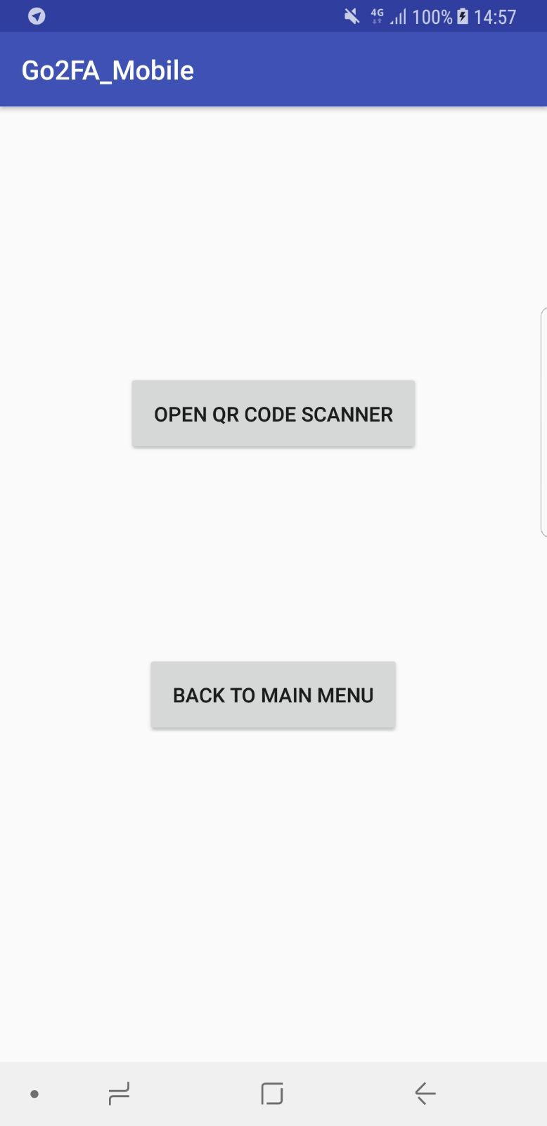

This page will appear when you select our OTP GENERATION function. This page lets you open the QR CODE SCANNER to help in generating OTP by scanning the QR CODE appeared when you are locking a file on your computer.

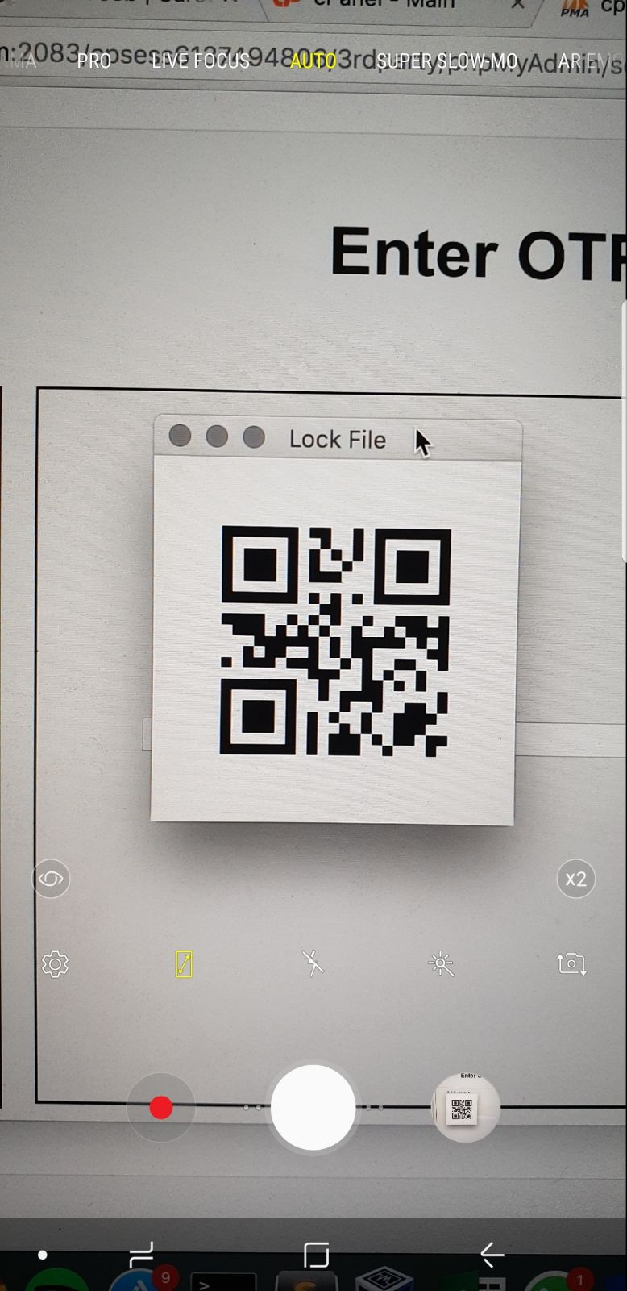

Upon selecting the OTP GENERATION function, the scanner will be open, and you can use it to scan the QR Code which appeared on your computer screen.

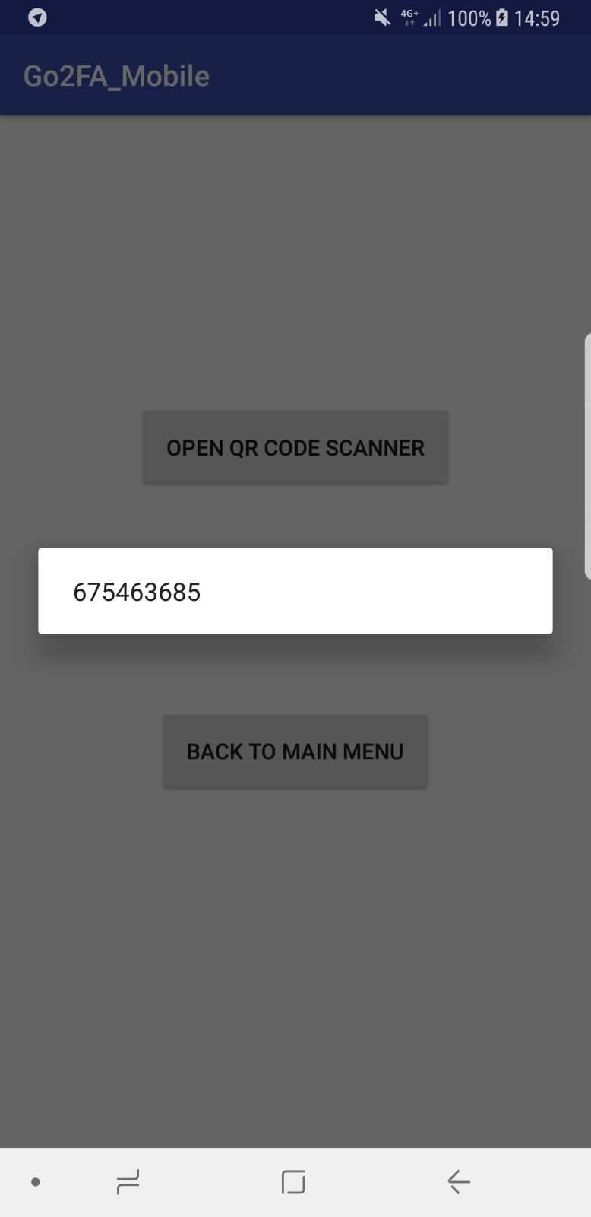

The scanner will decrypt the QR Code and OTP will be generated.

The OTP in the QRCode is cryptographically secured and can only be decrypted using our mobile application scanner.

\

## 5.2. Change Password

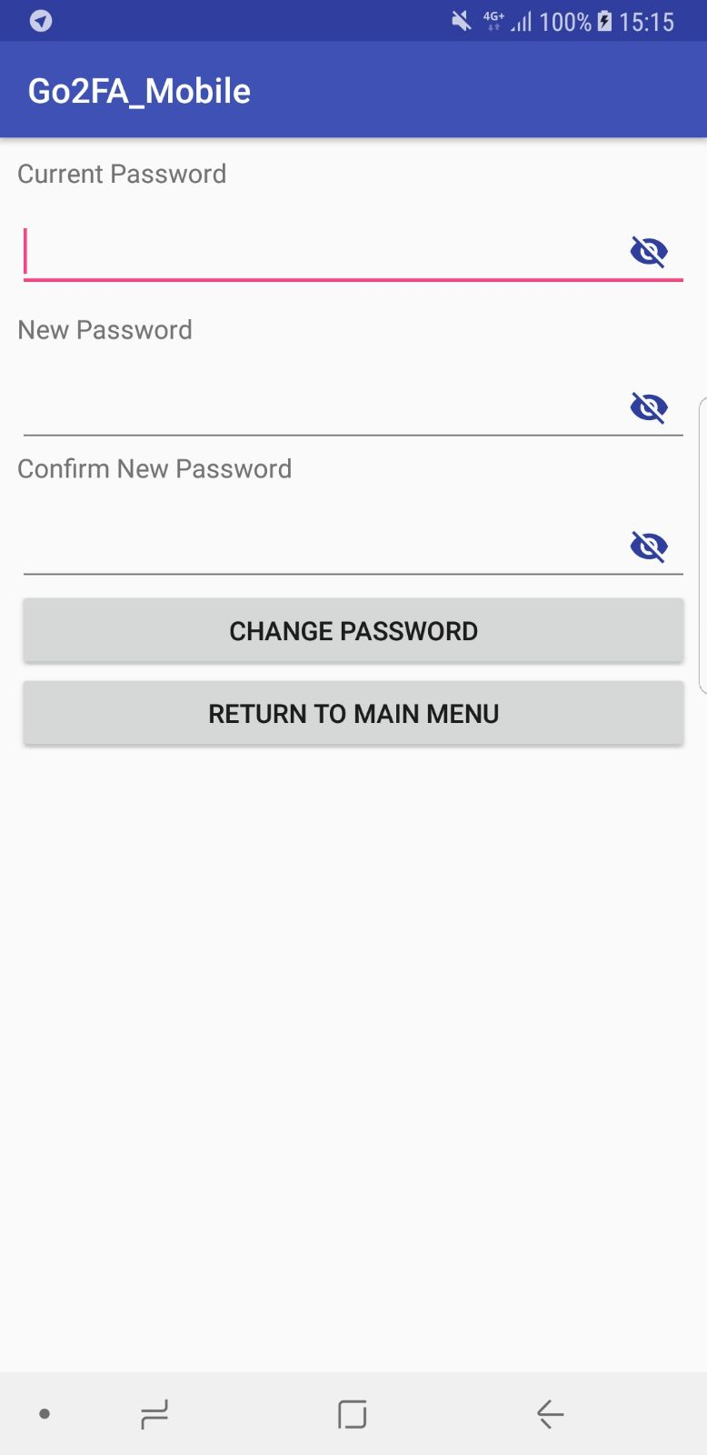

This page will appear when you select our CHANGE PASSWORD function. This page lets you change your existing password to a new desired password.

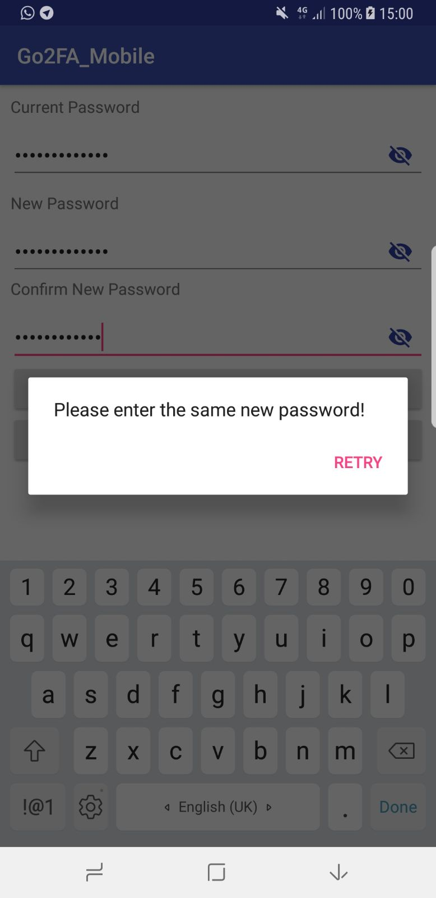

If the password you entered for the new password and confirm password does not match, a prompt message will appear indicating the mismatch and your password will not be changed.

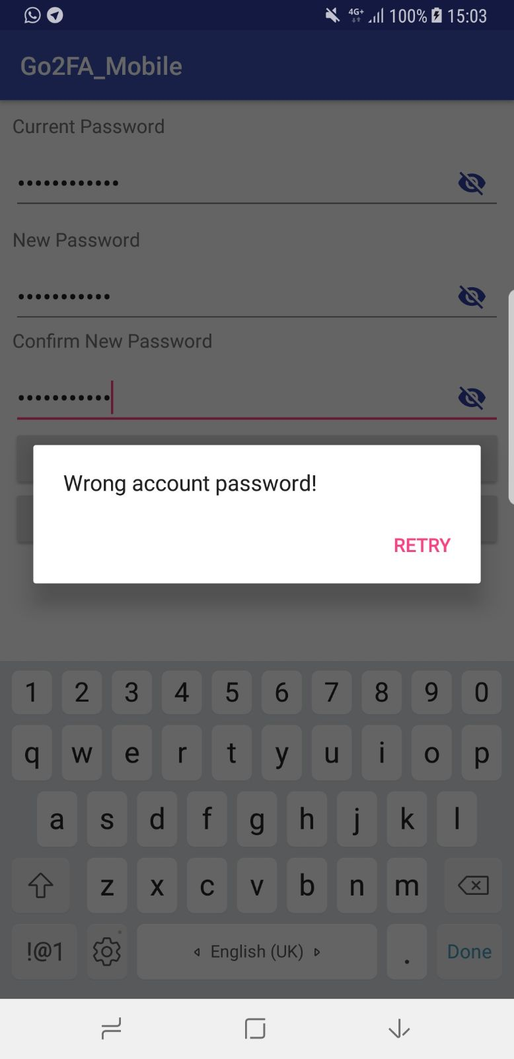

If the password you entered for the current password does not match with the record on our database, a prompt message will appear indicating the mismatch and your password will not be changed.

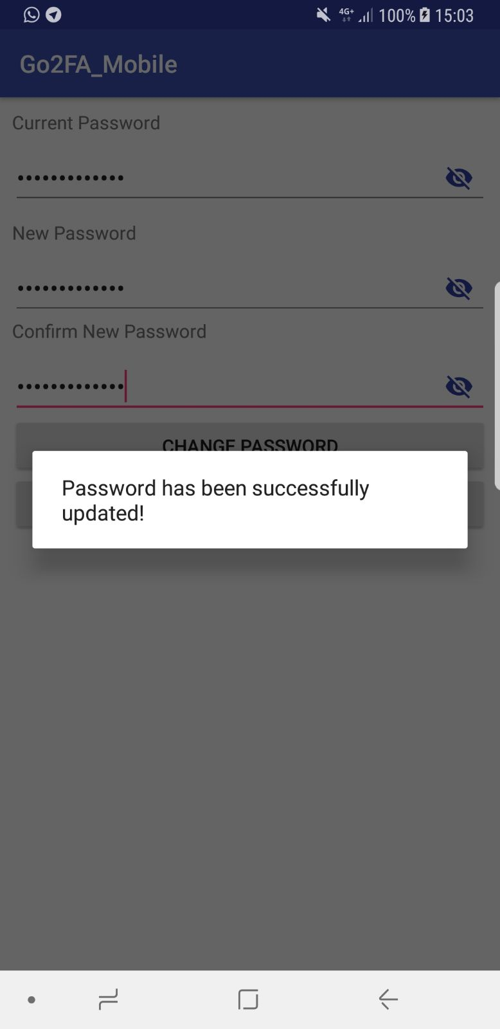

When you entered the password credentials correctly, your password will be successfully changed and updated in our database.